Summer 2019 Educator Externship
Handbook for Industry Partners
A Collaboration of Associated General Contractors
Oregon-Columbia Chapter
and
Willamette Promise, Willamette ESD

Frostia@agc-oregon.org

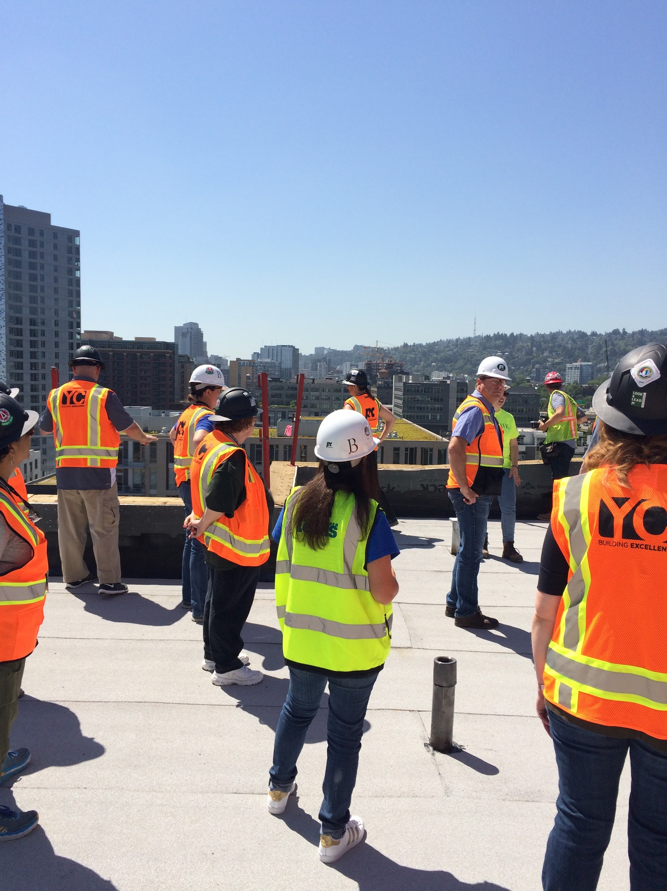

Overview and Purpose
The Educator Externship is a collaboration borne out of the AGC Oregon Columbia Chapter Workforce Coalition to bridge the gap between education and industry. It is an intensive eight-day program in the summer that exposes educators of all levels and subject matter to the diverse facets of the construction industry. Educators are expected to incorporate what they have learned about employability, skills, and career opportunities into their classroom or career center, with the goal of informing more students about these skills and opportunities and providing resources for students who may want to pursue a career in industry or trades.
During the eight-day course, educators spend five core days with industry partners and AGC member companies. AGC works with facilitators in all regions to schedule the days.
- Orientation and Safety Day: local apprenticeship and training centers
- General Contractor Day: site tours and project management
- Back Office Day: site tours, construction office overview, project estimation
- Heavy highway/roadway, quarry, and civil projects: site tours and overview
- Training programs: pre-apprentice and apprentice, certificate, two year, four year, and master’s degrees
- Local job shadow and exploration: connecting educators with companies in their immediate area to build partnerships on a local basis

Funding

Cost to the educators: none!
In fact, they receive a stipend for participating, and they pay only a minor transcription fee for their credits. Participants may incur some travel expenses, but the purpose of the stipend is to offset those expenses. The actual $1,450 cost of the program for each participant, including the stipend, credits, and grade transcription, is paid through several funding mechanisms, depending on the school district. They are primarily coordinated by Willamette Education Service District (WESD), in collaboration with the participating schools. However, funding mechanisms vary greatly statewide. Additionally, AGC funds positions through our grant process, which totaled $27,000 in 2018.

For educators to receive graduate level credit, they must complete all the work, attend every day of the course, and write a unit of study for their classroom or career center. For educators to receive professional development credit, they must complete all the work, attend every day of the course, and write a lesson plan incorporating the employability and career information they learned. Western Oregon University was our first partnering institution to offer credit for this course based on the rigor of the schedule. Through a partnership with Willamette Education Service District, the price of the program and graduate credits was significantly reduced. Cherie Clark (WESD) and Frosti Adams (AGC) are the instructors of record and they facilitate the course, write the syllabus and lessons, grade the work, and submit completed packets to WOU for grade entry.

Cost to industry partners: time, providing lunch optional
The purpose of this course and experience is to inform educators of all the hundreds of occupations that can be found within industry. We do that by having industry partners open their door for a day or half-day to re-image the construction world. Educators learn that there are so many high wage/high demand jobs in the various sectors of the construction and manufacturing industry that they never knew existed. The participating company gets to showcase their work, build bonds with local educators, remove misperceptions, and have employees look at their own industry from a new perspective.
Course Objectives – Examples of What You Would Cover

Orientation and safety in the workplace (training provided by AGC safety management consultants (SMC) or other trained safety professional)

- Intro (ESD/AGC)  - Goals of orientation (ESD/AGC)  - Safety stats  - Where accidents occur  - Why  - Slips, trips, and falls  - Caught between | - Struck by  - Electrical shock  - Hierarchy of controls  - Personal protective equipment (PPE)  - Top ten safety rules to live by  - Questions

Apprenticeships and training centers such as Northwest College of Construction (NWCOC), National Electrical Contractors Association (NECA)/International Brotherhood of Electrical Workers (IBEW), Pacific Northwest Carpenters Institute (PNCI), Sheet Metal Institute (SMI), Independent Electrical Training Center (IETC)

- Application  - Point process  - How to improve your score  - Interview process  - Resume | - Types of programs  - Admissions  - Work-training relationship  - Funding

General Contractor Day: Help educators gain an in-depth understanding and appreciation for construction management. This day is typically a full day with lunch provided for 12–15 educators. Site tours are usually conducted in the morning, then lunch out or back at your office, then a project management exercise at your office. It works well to bring in a young project manager that the educators relate to. We can provide project ideas, or you can use an existing project.

- Site tours  - Bidding  - Management roles  - Estimating  - Marketing | - Relationships and teamwork  - Training and education needed

Construction Office Management Day (aka Back Office): This is a day that shows other career options within the industry, and explains how industry uses business professionals with expertise in the day to day office management of a company. This is typically a full day with lunch provided for 12–15 educators, depending on the region. Site tours are usually conducted in the morning, then lunch out or back at the office, with an estimating or design project for the educators. We can provide existing projects or you can use one of your own.

- Subcontracting  - Estimating  - Accounts payable/receivable  - Payroll  - Invoices | - Human resources  - IT  - Public relations  - Marketing

Highway, Roadwork, Quarry, Civil Engineering: This day is usually very popular with the educators because it is unique, yet omni-present. Depending on projects in the region, this could be half a day or full day for 12–15 educators. Sometimes this day is shared between two companies, with lunch in between. For remote locations, the educators could bring their own sack lunch on this day. In some regions, this day is shared with community college or training centers.

- Safety  - Quarry  - Removal and crushing  - Size  - Using rock in asphalt | - Using rock in concrete  - Trucking  - Construction on a road  - Earthwork, roads, bridges, and signage

Local Shadow and Explore (LSE): This is one of the most important days for fostering relationships and building connections between businesses and local schools. Since this day is flexible, it will be designed to meet the needs in various sectors and regions. In some regions, large local employers may be showcased to the entire group of educators, while in other areas a smaller local employer may take a small group of 1–3 for ride-alongs. Scheduling is collaborative between AGC and regional facilitators. Lunch is provided by the industry partner or the educator, depending on the day’s schedule.

- Staff meetings
- Planning meetings
- Management meetings
- Panel discussions
- Job shadow ride-alongs
- Career pathways
- Observation of job skills within core teaching content areas

Community College Connection: It is vitally important that educators understand the pre-apprenticeship and certificate programs offered at their local community college. This helps educators and counselors to determine pathways for students expressing a desire to enter a particular trade. This is a full or half day depending on the region and programs offered. It is sometimes combined with Highway, Roadwork, Quarry, Civil Engineering Day. Lunch details vary.

  - Certificates
  - Associate of Applied Science (AAS) two-year terminal and stackable degrees
  - Transfer degrees
  - Application and limited enrollment programs
  - Scholarships
  - Industry partnerships

University Connections: The final day of the Educator Externship includes touring a local university, a debrief on the experience, and collaboration on lesson plans. Lunch is provided by the university for the entire group of educators from a region.

- University presentations: PhD projects, emerging issues, and innovation
- Solutions on the horizon
- University tour
- Bachelor’s and master’s programs
- Emerging careers
- New sector strategies
- Exploring curriculum alignment with post-secondary

Notes and Questions:

